Chapter 15, Solution 43.

- For 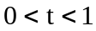, 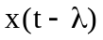 and 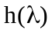 overlap as shown in Fig. (a).
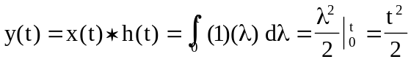
0
(b)
1
t
t-1
●
1
0
(a)
x(t - )
h()
1
t
t-1
●
1

For 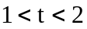, and overlap as shown in Fig. (b).
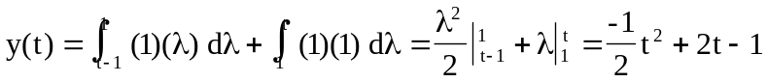

For 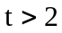, there is a complete overlap so that
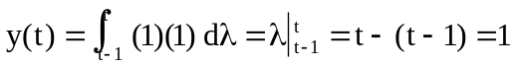

Therefore,
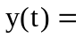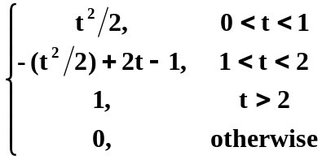

- For 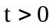, the two functions overlap as shown in Fig. (c).
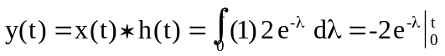
(c)
x(t-)
0
t
●
h() = 2e^{-}
1
2
Therefore,
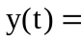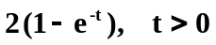

- For 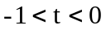, and overlap as shown in Fig. (d).
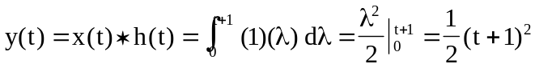
0
(d)
x(t - )
h()
1
t
t-1
●
1
t+1
-1
2

For , and overlap as shown in Fig. (e).
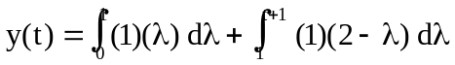
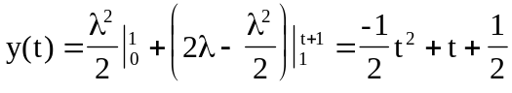
0
(e)
1
-1
t-1
●
1
t+1
2
t

For , and overlap as shown in Fig. (f).
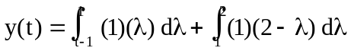
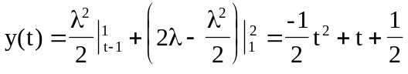
t+1
0
(f)
1
t-1
●
2
t
1

For 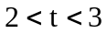, and overlap as shown in Fig. (g).
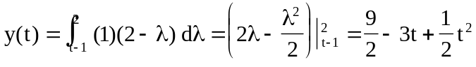
t+1
0
(g)
1
t-1
●
2
t
1

Therefore,
